Old Catholic Communion
Holy Synod 2023
Affirmation Process for delegates

Delegates elected through the Synodal Process and who have been designated by their Parish/Community will participate in the Affirmation process.
Our Communion and our Constitution encourages us to “listen to all voices.” Consensus is the preferred method of affirmation. If a situation occurs at Holy Synod where consensus among the delegates cannot be reached, then a vote of the delegates is required.

All materials should be reviewed with the Parish/Community prior to Holy Synod in order for delegates to accurately and faithfully convey the consensus of the parish or community that they represent.

Hosting a hybrid Holy Synod with people attending via zoom and in-person presents a unique situation for the process of affirmation.

The information below outlines the process for all delegates (zoom and in person) to participate in the affirmation process during Holy Synod.

Consensus by the delegates:

Consensus decision making refers to the process among a gathered group by which decisions are made by seeking the mind of Christ, not by “voting their own mind.” The mind of Christ will be revealed by an uncoerced unanimity among the participants, reached after thorough faith-filled discussion and prayer. Decisions so made are reflective of the diversity of the Church and are a better way of reflecting the nature of the Church.
Consensus is a common consent; a general acceptance about a proposal, idea, or opinion shared by all people in a group. It represents agreement, harmony, and compromise.
A roll call of delegates will be made to identify those who are present (zoom and in person) and eligible to participate.
Each item being considered for affirmation will be presented and delegates will be asked for a consensus decision. In person and zoom participants will be asked to affirm their decision.
If it is not possible to reach consensus, and after further discussion, there is agreement that consensus cannot be reached, then a vote by the delegates is required. Failing to reach consensus and a vote by the delegates should be viewed as the final option. Delegates will need to vote via zoom and in person and two processes have been developed if the need arises.
In-Person affirmation if consensus is not reached:
A roll call of delegates will be made to identify those who are present to participate.
A paper ballot with a place for the delegate name, Parish/Community and a “yes” or “no” vote will be provided.
The Laity Chair and the Recorder of the Synod will receive and count the ballots indicating the total of “yes” and “no” responses.
Once the final total of yes and/or no votes has been determined, the ballots will be destroyed.
Zoom affirmation if consensus is not reached:

Members on zoom can vote directly from their computer screen following this process:

- Click on “chat” at the bottom of your computer zoom screen (you may need to move your mouse toward the bottom of the screen so the line of icons appears)
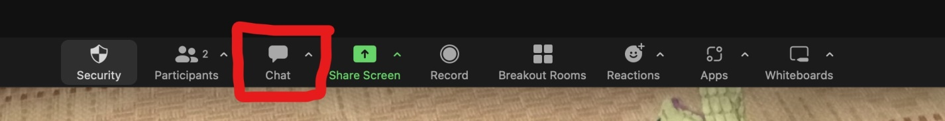

- Locate the white box and the statement: “Who can see our message?”
- For ALL affirmations except SC Laity Chair…select: Cheryl Renneckar and Reverend Rosemary Burdick
- For affirmation of the Laity Chair…select: Reverend Rosemary Burdick. A second person will verify the vote.
- Where it says “Type your message here”…type either “yes” or “no” and send (arrow box at bottom right)

The responses will tabulated and compared to be sure that the responses and totals match.
No record will be kept of an individual’s response!
Only the total number of “yes” or “no” votes will be tallied and reported.

Final Affirmation:

If consensus is achieved, the result will be announced.
If consensus cannot be achieved and a vote of the delegates is required, then all of the in-person and zoom delegate votes will be tallied and the final total and result announced.

OCC SC/HOB April 2023

